TOPIC -1 PROGRAMS

Example Code: Benefits of Data Wrangling
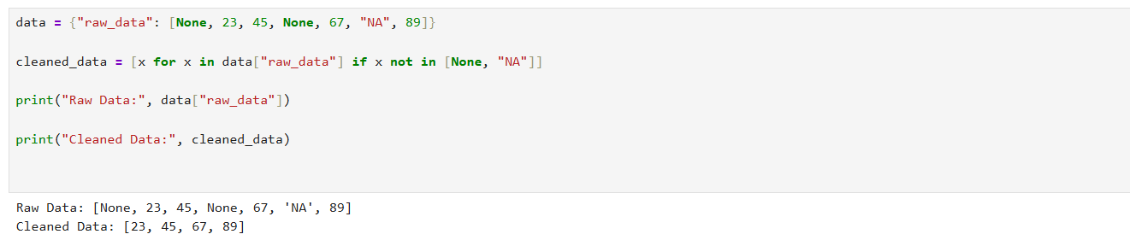

Example Code: Cleaning Data
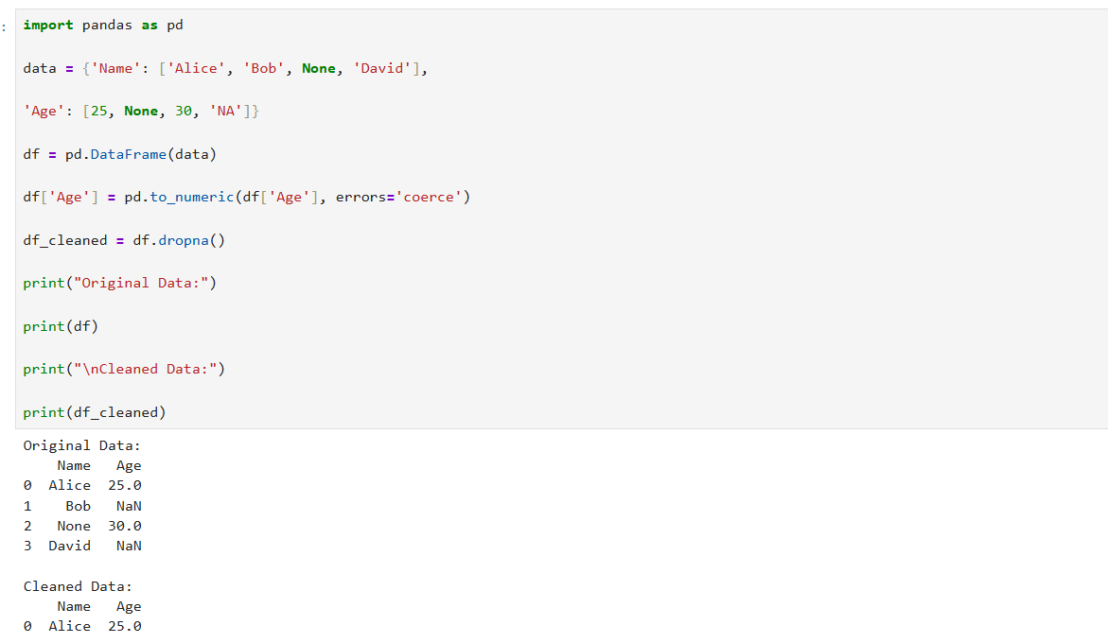

Example Code: Normalizing Data
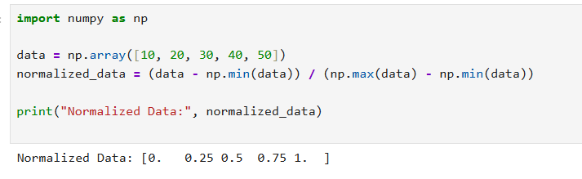

Example Code: Basic Syntax
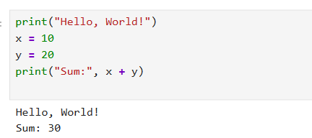

Example Code: Reading and Writing CSV
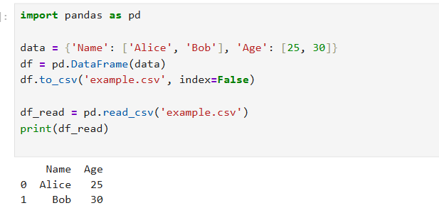

Example Code: Reading JSON
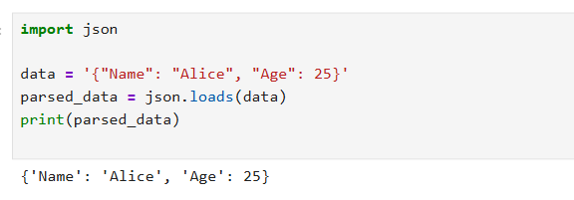
Example Code: Parsing XML
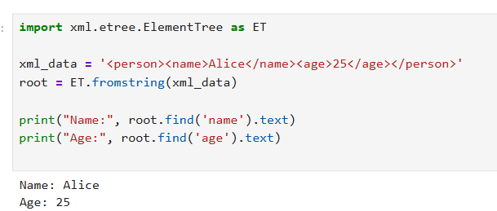

Example Code: Retrieving Schema Using SQLite
